|  |  |  |
| --- | --- | --- |
| **LAB221 Assignment** | **Type:** | **Long Assignment** |
| **Code:** | **J2.L.P0021** |
| **LOC:** | **300** |
| **Slot(s):** | **5** |

**Title: Number Puzzle Game**

**Background**

The number-puzzle (also called Mystic Square and many others) is a sliding puzzle that consists of a frame of numbered square tiles in random order with one tile missing. The puzzle exists in some sizes. If the size is 3×3 tiles, the puzzle is called the 8-puzzle or 9-puzzle, and if 4×4 tiles, the puzzle are called the 15-puzzle or 16-puzzle named, respectively, for the number of tiles and the number of spaces. The object of the puzzle is to place the tiles in order by making sliding moves that use the empty space.

**History**

The eight-puzzle is a smaller version of the fifteen-puzzle, which was invented in 1874 by Noyes Palmer Chapman, a postmaster in Canastota, New York. The puzzle made its way to Hartford, Connecticut, where students in the American school of the Deaf started manufacturing the puzzle and, by December 1879, selling both locally and Boston. Then the puzzle became a craze in the U.S. in Feb 1880.

**Program Specifications**

**Number Puzzle Game (NPG)** is a small program that displays an NxN grid size of buttons. When the game loaded, the grid 3x3 is filled with the 9 buttons with titles randomized from 1 to 8 and the 9th is empty. The gamer moves the title button to exchange the location with the empty to win the game.

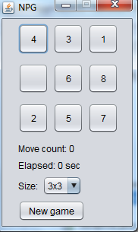

Figure 1-Start the game 3x3

**Rules**

To move: If there is an empty adjacent square next to a tile, a tile may be slid into the empty location.

For example: In figure 1: 4, 6, 2 titles can slide to the empty one.

To win: The tiles must be moved back into their original positions, numbered 1 through 8.

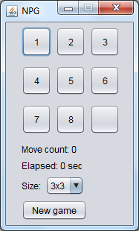

Figure 2-Win the game

**Features:**

-Gamer can choose the puzzle size 3x3 or 4x4

-Start a new game

-Display the Move count and Elapsed time

-Display congratulation when the user wins the game

**Guidelines**

-Use GridLayout to display titles and empty.

-Use thread to display elapsed time.